The Birth of Galaxies
Answer the following questions True or False:

1. We have photos of what happened during the first 300 000 years of the universe. _________________

2. Scientists work out the first 300 000 years from watching super models.

__________________

3. A faint glow in space is the only evidence of the Big Bang Theory.

__________________

4. Slightly warmer and cooler gas can be seen from spacecraft and telescopes.

__________________

5. Over millions of years material was pulled into denser areas by gravity.

__________________

6. In the beginning stars were being born at a rate 100 times faster than present.

__________________

7. Clusters of stars became planets.

__________________

8. Powerful telescopes can find galaxies that were created over a billion years ago.

__________________

9. Our galaxy is the Snickers galaxy.

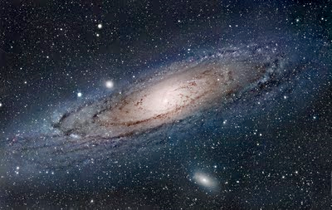
__________________

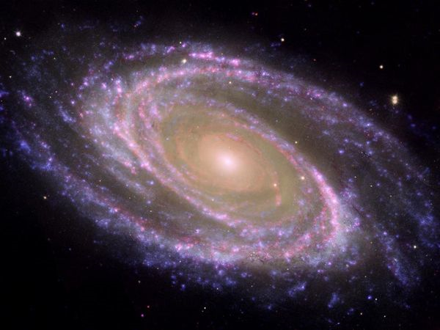
The Birth of Galaxies
Use the information below to answer your True/False questions:

How many did you get right?

___________________

Answer the following questions:

We cannot see anything that happened during the first 300 000 years of the Universe. Scientists try to work it out from their knowledge of atomic particles and from computer models.

1. How do scientists work out what happened in the first 300 000 years of the Universe?

_____________________________________________________________________

_____________________________________________________________________

The only direct evidence of the Big Bang itself is a faint glow in space. Spacecraft and telescopes on balloons see this as a patchy pattern of slightly warmer and cooler gas all around us. These ripples also show where the hydrogen clouds were slightly denser.

2. What is the evidence of the Big Bang? _______________________________

_____________________________________________________________________

3. What do spacecraft and telescopes see the above as? ___________________

_____________________________________________________________________

_____________________________________________________________________

As millions of years passed, the dense areas pulled in material because they had more gravity. Finally, about 100 million years after the Big Bang, the gas became hot and dense enough for the first stars to form.

4. What happened to the dense areas as millions of years passed? __________

_____________________________________________________________________

5. What happened about 100 million years after the Big Bang? ____________

_____________________________________________________________________

_____________________________________________________________________

New stars were being born at a rate 10 times higher than in the present-day Universe. Large clusters of stars soon became the first galaxies.

6. Are stars being born faster or slower now, than in the past? _____________

7. What did the large clusters of stars form? ____________________________

The Hubble Space Telescope and powerful ground-based telescopes are now beginning to find galaxies that were created about one billion years after the Big Bang. These small galaxies were much closer together than galaxies are today. Collisions were common. Like two flames moving towards each other, they merged into bigger galaxies. Our Milky Way galaxy came together in this way.

8. What are the Hubble Space Telescope and powerful ground-based telescopes finding?
_____________________________________________________________________

_____________________________________________________________________

9. How were galaxies of the past different to galaxies today? ______________

_____________________________________________________________________

10. Explain how our Milky Way came together __________________________

_____________________________________________________________________

_____________________________________________________________________

